

**Requirements Analysis & Planning Document**

Project name: Data Access and Management



December 8, 2018

Team: CPP Developers

**1 Problem Overview**

**1.1 Introduction**  
This project is based on creating a database which will provide the services to students like providing information sources and searching about articles according to their requirements.

**1.2 Statement of Problem or Need**   
The school students need articles for their preparation of exams or for their knowledge about particular subjects which they are only able to find in some books. They find it difficult to search in the books and they have to go to library and go through numerous books to find their information material or sometimes they have to go on the internet to google it.

Therefore, it is a good and reliable idea of creating a website or application (if using mobile or similar gadgets) which will contain all the required studying material which students need on their daily basis.

**1.3 Description of Current Situation**

**1.3.1 Current process diagram**

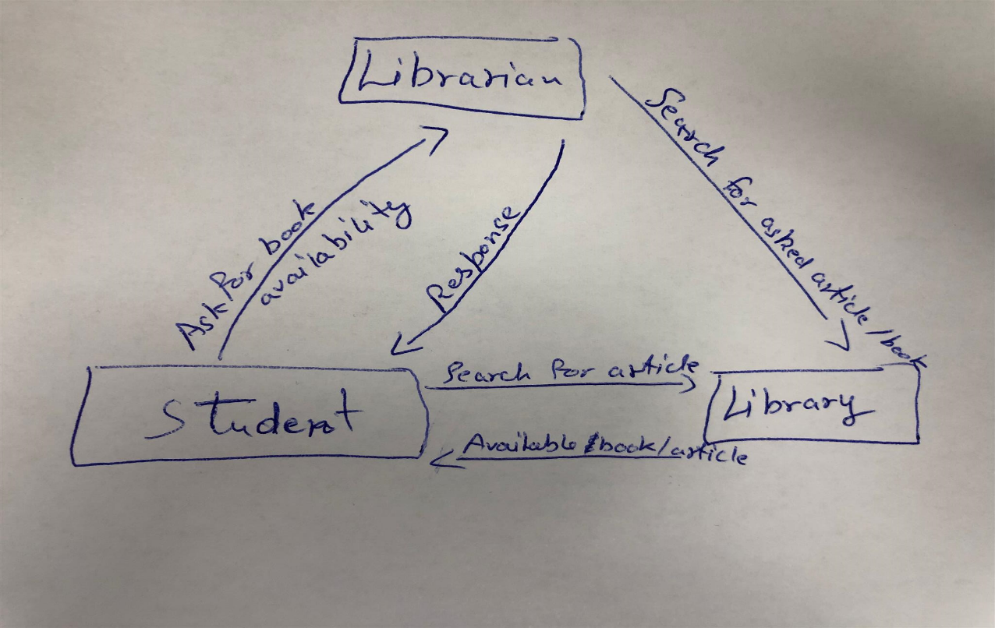

**List of current process for the Students**

* + Students go the librarian and ask about the availability of the required book containing the required article or required study material.
  + Students get instructions by their teacher to find the articles or particular information about any particular subject.
  + They go and find it through various sources like books (this consumes their time and sometimes not able to find it in the given time)

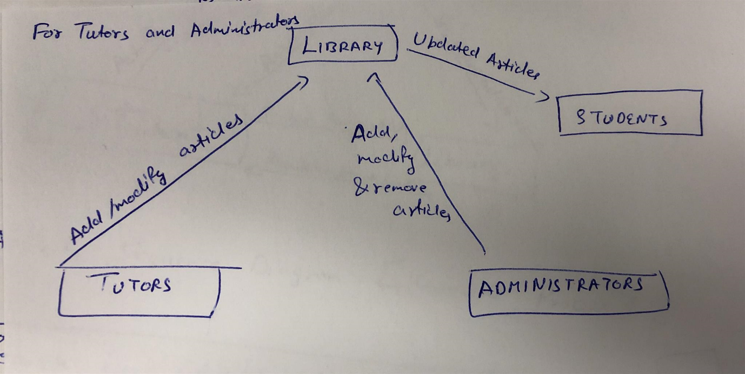

**List of current process for the Tutors and Administrators**

* Tutors go to the library and keep the books according to the students’ classes/levels.
* They keep on updating/changing the books and other material according to the changing syllabus.

**1.3.3 Activity sequence diagrams for current processes**

**Activity Sequence diagram for students**

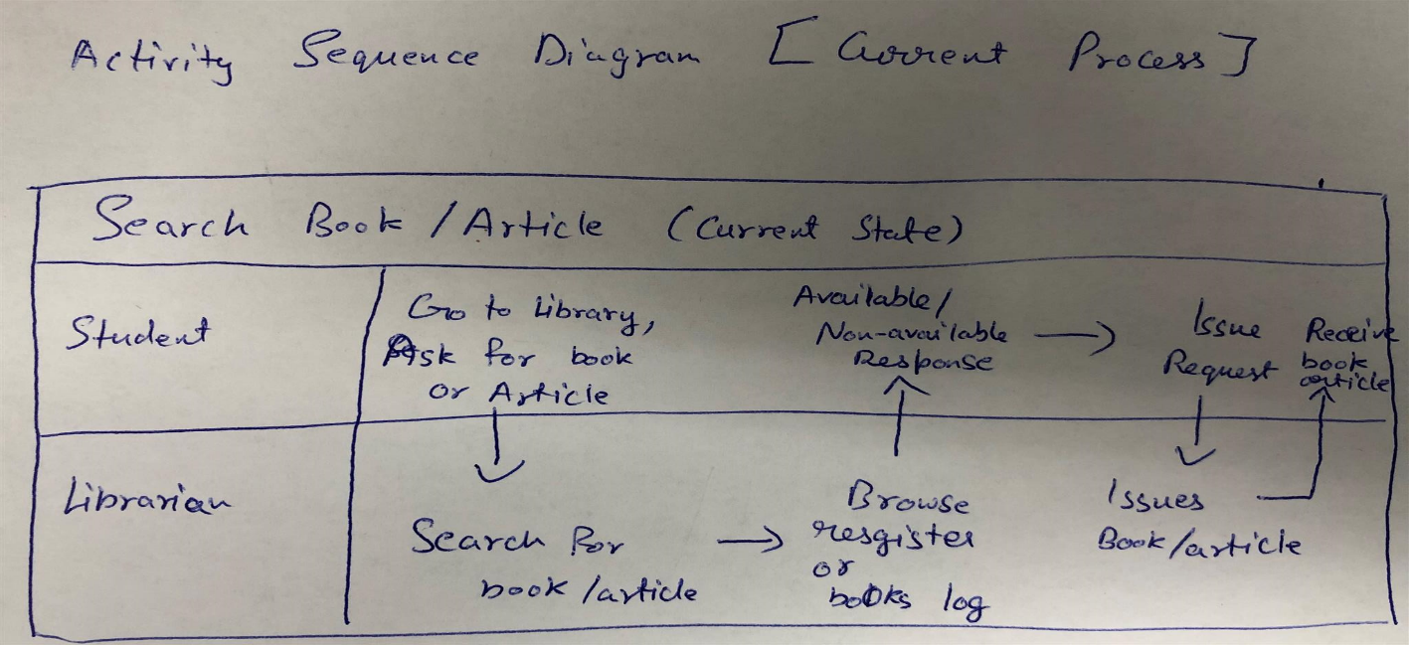

**Activity sequence diagram for tutors and administrators**

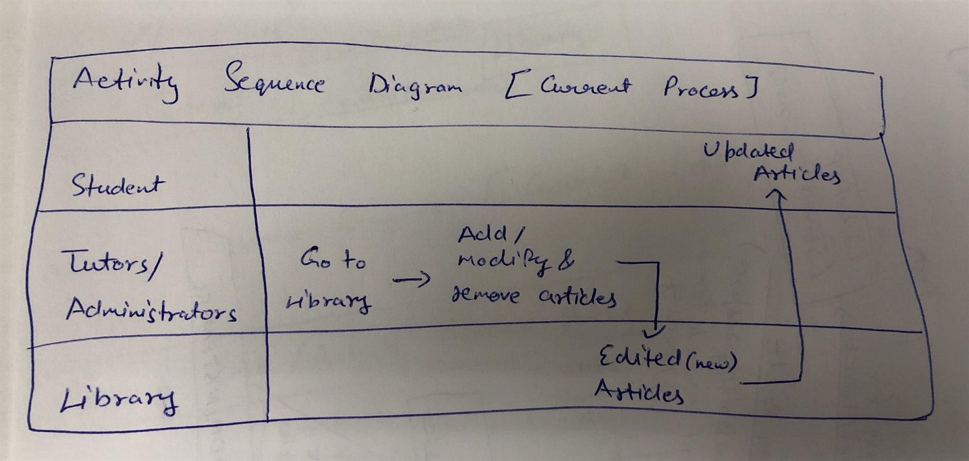

**2 Future Requirements**

**2.1 Future Requirements**

For solving this problem, there is a solution which is described below containing the information or data about creating website and accounts.

**2.1.1 Brief description of future procedure**

There will be a website or application which will contain all the study material and article material of the learning part and other necessary things which students often need on some required period of time. For this, tutors, administrators and students will be provided personal and secured accounts to access through the website and do their tasks and activities.

**2.2 Description of Future State**

**2.2.1 Future state system context diagram for Students, Tutors and Administrators**

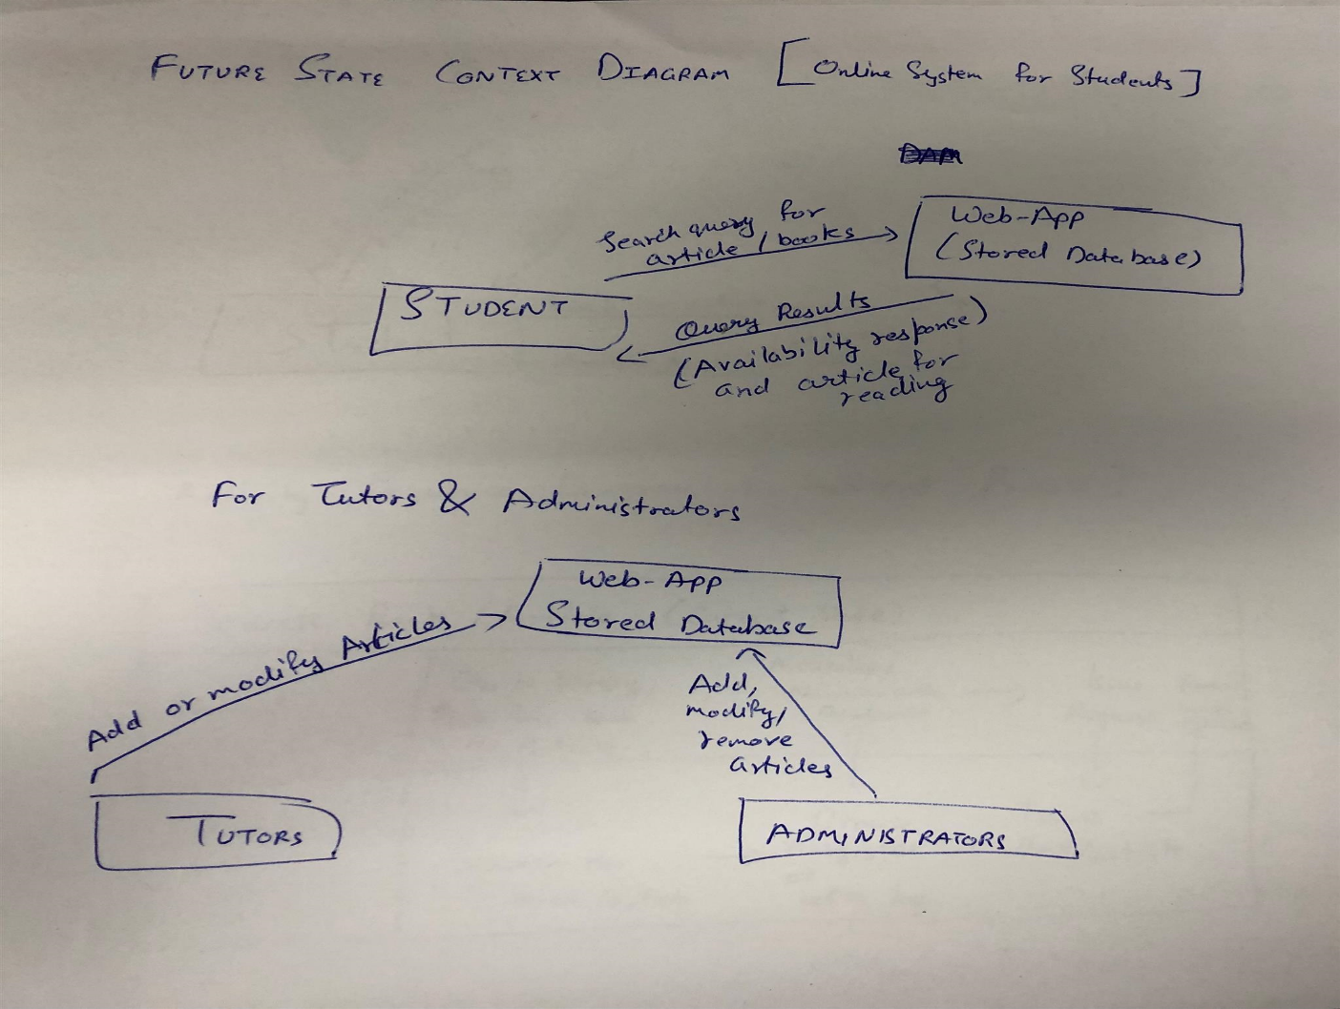

**2.2.2 Future processes**

* + As described above, a website or application will be created which will be having the studying content.
  + After that, accounts will be created and issued to the administrators, teacher and students, which they will use to access through the website to get their content.
  + The administrators will be able to upload the data to the teachers’ accounts and also be able to solve their problems if teachers’ face on any time. That is, sometimes if they are not able to access through any particular study material, the administrators can help them to solve it.
  + The teachers will be able to provide the study material to the students whatever they ask for, according to the subject a teacher teaches.
  + The students will be able to get their requirements which they asked from the teachers and can find it uploaded in their accounts, instantly. Along with that, they can be able to search or explore other information sources through the website for their other important purpose related to their studies.

**2.2.3 Activity sequence diagram for students (future process)**

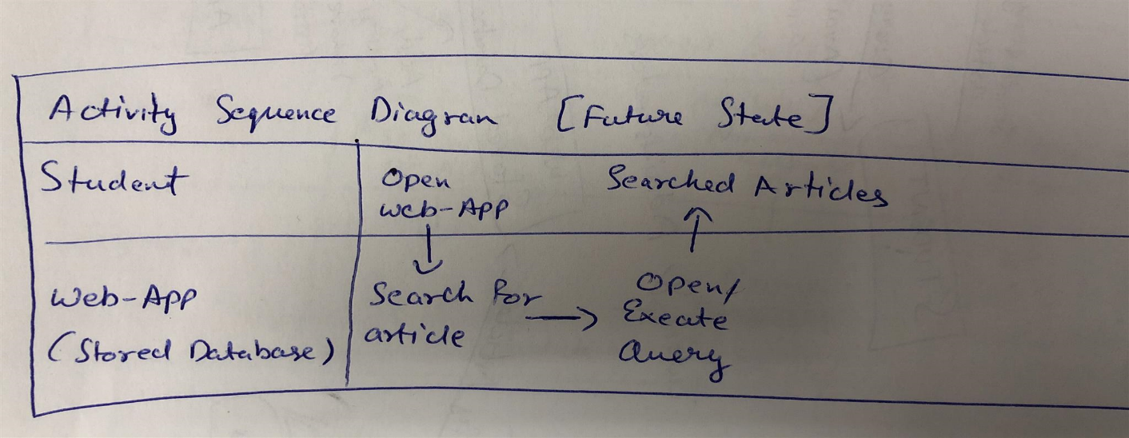

**2.2.4 Activity sequence diagram for tutors and administrators (future process)**

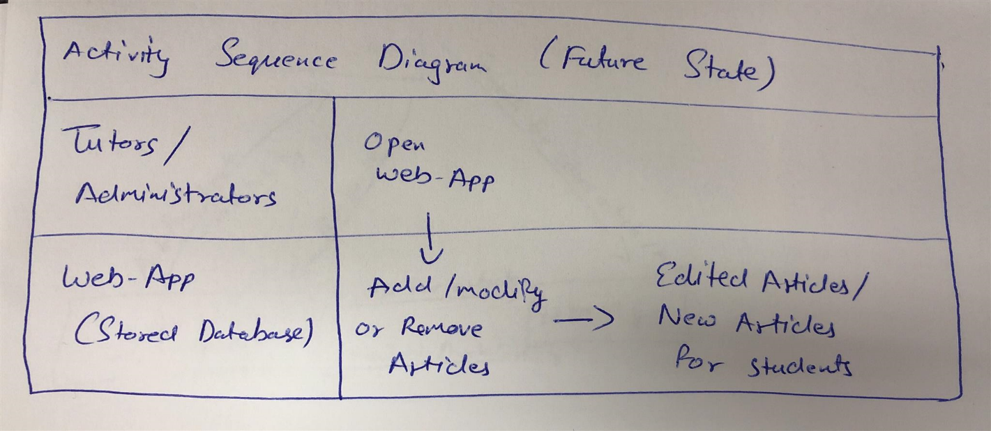

**3 Iteration planning**

**3.1 Iteration 1:** Developing System Design document

In Iteration 1, our team will analyze the data and we will create a solution design document outlining Architecture, Database Model, User Access and UX Design.

Due Date: 11/12/2018

**3.2 Iteration 2:** Developing the Database

In Iteration 2, we will be creating a database in a selected database management system using the test data provided in course. We will use SQL Server Management Studio and MySQL Workbench 8.0 CE.

Due Date: 12/12/2018

**3.3 Iteration 3:** Developing Database Queries

In Iteration 3, our team will create queries as per client’s requirements.

Due Date: 12/12/2018

**3.4 Iteration 4:** User Access Implementation Suggestions

In Iteration 4, we will be creating some suggestions on implementing the user access in the approved DBMS.

Due Date: 12/12/2018